CS8383
OBJECT ORIENTED PROGRAMMING
LABORATORY

LAB MANUAL

Prepared By,
Rajasekaran S
Assistant Professor
KGISL Institute of Technology
Coimbatore.
Email:proffraja@gmail.com

INDEX
S No | Experiment | Marks | Sign
1 | Electricity Bill Calculator
2 | Unit Converters Application using packages
3 | Employee Payroll System
4 | Java Application for ADT Stack using Interfaces
5 | Java Application for String Operations using ArrayList
6 | Java Application to Find the Area of different Shapes
7 | Bank Transaction System with User Exceptions
8 | Java Application for File Handling
9 | Java Application for Multi threading
10 | Java Application for Generic Max Finder
11 | Calculator Application using java AWT packages

Important Links

Ex.No: 1 | Electricity Bill Calculator
Date: | Electricity Bill Calculator

Aim:

To create a Java console application used to generate electricity bill based on connection type (Domestic and Commercial) and consumption. Both are having different tariff slots.

Algorithm:

Step 1 | Start the process
Step 2 | Get the user informations [Name, Consumer Number, Reading’s of previous and current month, Connection Type]
Step 3 | Compute units consumed by user [Current Month Reading – Previous Month Reading]
Step 4 | If a connection type is domestic goto step 6
Step 5 | Else goto step 7
Step 6 | Initialize i with 1 and sum as 0
 | Step 6.1 | If check i is less than or equal to 100 then compute sum = sum + 1 and goto step 6.5
 | Step 6.2 | Else if check i is greater than 100 and less than 200 then compute sum = sum + 2.5 and goto step 6.5
 | Step 6.3 | Else if check i is greater than 200 and less than 500 then compute sum = sum + 4 and goto step 6.5
 | Step 6.4 | Else compute sum = sum + 6 and goto step 6.5
 | Step 6.5 | If i is equal to number of units consumed goto step 8 else return to same step
Step 7 | Initialize i with 1 and sum as 0
 | Step 7.1 | If check i is less than or equal to 100 then compute sum = sum + 2 and goto step 7.5
 | Step 7.2 | Else if check i is greater than 100 and less than 200 then compute sum = sum + 4.5 and goto step 7.5
 | Step 7.3 | Else if check i is greater than 200 and less than 500 then compute sum = sum + 6 and goto step 7.5
 | Step 7.4 | Else compute sum = sum + 7 and goto step 7.5
 | Step 7.5 | If i is equal to number of units consumed goto step 8 else return to same step
Step 8 | Store the sum
Step 9 | Display Bill Details [Name, Consumer Number, No of units consumed]
Step 10 | Check the connection type
 | Step 10.1 | If connection type is domestic display domestic tariff slot and goto step 11
 | Step 10.1 | Else display commercial tariff slot and goto step 11
Step 11 | Display amount payable using stored sum
Step 12 | Stop the Process

Coding

import java.util.Scanner;
class EBConsumer {

int consumer_number;
String consumer_name;
int previous_month_reading;
int current_month_reading;
int units_consumed;
boolean isDomestic = false;
double bill_ammount;

public void displayDomesticFares(){
System.out.println("Domestic Fare Details");
System.out.println("*********************");
System.out.println("First 100 units - Rs. 1 per unit");
System.out.println("101-200 units - Rs. 2.50 per unit");
System.out.println("201 -500 units - Rs. 4 per unit");
System.out.println("> 501 units - Rs. 6 per unit");
}

public void displayCommercialFare() {
System.out.println("Commercial Fare Details");
System.out.println("***********************");
System.out.println("First 100 units - Rs. 2 per unit");
System.out.println("101-200 units - Rs. 4.50 per unit");
System.out.println("201 -500 units - Rs. 6 per unit");
System.out.println("> 501 units - Rs. 7 per unit");
}

public void getDetails() {
Scanner inputs = new Scanner(System.in);
System.out.println("Welcome To EB Calculater\n\n");
System.out.println("Please Enter Your Name : ");
this.consumer_name = inputs.next();
System.out.println("Please Enter Your Consumer Number : ");
this.consumer_number = inputs.nextInt();
System.out.println("Please Enter Your Previous Month Reading : ");
this.previous_month_reading = inputs.nextInt();
System.out.println("Please Enter Your Current Month Reading : ");
this.current_month_reading = inputs.nextInt();
System.out.println("Is this domestic Connection (yes/no) : ");
if(inputs.next().equals("yes"))
this.isDomestic = true;
}

public void generateBill(){
int number_of_units_consumed = this.current_month_reading - this.previous_month_reading;
this.units_consumed = number_of_units_consumed;
double sum = 0;
if(isDomestic == true) {
for (int i = 0; i <= number_of_units_consumed; i++) {
if (i <= 100)
sum = sum + 1;
else if (i > 100 && i <= 200)
sum = sum + 2.5;
else if (i > 200 && i <= 500)
sum = sum + 4;
else
sum = sum + 6;
}

}
else {
for (int i = 0; i <= number_of_units_consumed; i++) {
if (i <= 100)
sum = sum + 2;
else if (i > 100 && i <= 200)
sum = sum + 4.5;
else if (i > 200 && i <= 500)
sum = sum + 6;
else
sum = sum + 7;
}
}
this.bill_ammount = sum;
}

public void displayBill() {
generateBill();
System.out.println("The EB Bill Details");
System.out.println("*******************");
System.out.println("Consumer Number : "+this.consumer_number);
System.out.println("Consumer Name : "+this.consumer_name);
System.out.println("Consumer Units Consumed:"+this.units_consumed);
if(this.isDomestic == true)
System.out.println("Your are an Domestic Consumer\nFare Details ...");
else
System.out.println("You are a Commercial Consumer\nFare Details ...");
System.out.println("\nAmount Payable is \u20B9: "+this.bill_ammount);
}
}

public class Main {

public static void main(String[] args) {
EBConsumer consumer = new EBConsumer();
consumer.getDetails();
consumer.displayBill();
}
}

Output:

User type is domestic:

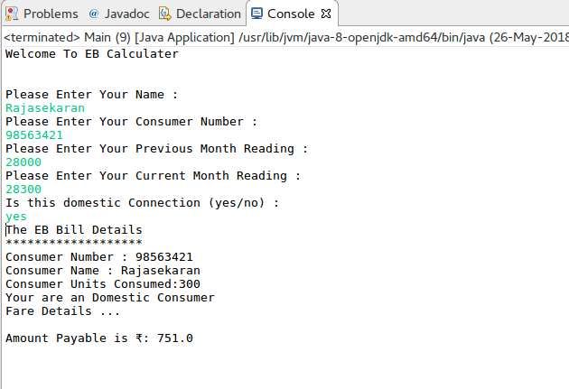
User type is commercial:

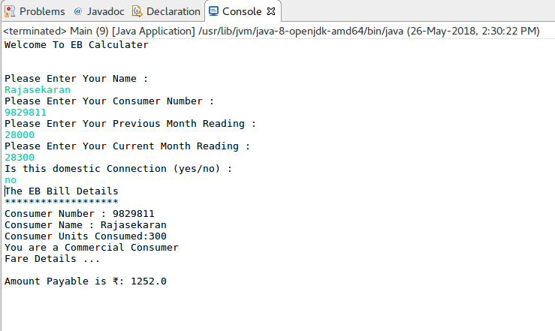

Result:

The Java console application for electricity bill generator was developed and tested successfully.

Ex.No: 2 | Unit Converters Application using packages
Date: | Unit Converters Application using packages

Aim:

To create a Java console application that converts currency, distance, time. Converter classes must be separated and used based on the package concept in java.

Algorithm:

Step 1 | Start the process
Step 2 | Prompt the user with converter choice 1. Currency 2.Distance 3. Time 4. Exit and the choice.
Step 3 | If user selects a Currency Converter then proceed to step 4
Step 4 | Proceed with prompting Currency Converter Choices  1. DOLLER to INR 2. EURO to INR 3. YEN to INR  4. INR to DOLLER 5. INR to EURO 6. INR to YEN  7. Exit and get the user choice.
 | Step 4.1 | If option 1 selected get in DOLLER and display DOLLER * 66.89 as INR
 | Step 4.2 | If option 2 selected get in EURO and display EURO * 80 as INR
 | Step 4.3 | If option 3 selected get in YEN and display YEN * 0.61 as INR
 | Step 4.4 | If option 4 selected get in INR and display INR / 66.89 as DOLLER
 | Step 4.5 | If option 5 selected get in INR and display INR / 80 as EURO
 | Step 4.6 | If option 6 selected get in INR and display INR / 0.61 as YEN
 | Step 4.7 | If option 7 selected exit from currency converter choice goto step 2
Step 5 | If user selects a Distance Converter then proceed to step 6
Step 6 | Proceed with prompting Distance Converter Choices  1. METER to KILOMETER 2. MILES to KILOMETER  3. KILOMETER to METER 4. KILOMETER to MILES  5. Exit and get the user choice.
 | Step 6.1 | If option 1 selected get in METER and display METER / 1000 as KILOMETER
 | Step 6.2 | If option 2 selected get in MILES and display MILES * 1.60934 as KILOMETER
 | Step 6.3 | If option 3 selected get in KILOMETER and display KILOMETER * 1000 as METER
 | Step 6.4 | If option 4 selected get in KILOMETER and display KILOMETER / 1.60934 as MILES
 | Step 6.5 | If option 5 selected exit from distance converter choice goto step 2
Step 7 | If user selects a Time Converter then proceed to step 8 currency
Step 8 | Proceed with prompting Time Converter Choices  1. HOURS to MINUTES 2. HOURS to SECONDS  3. MINUTES to HOURS 4. SECONDS to HOURS  5. Exit and get the user choice.
 | Step 8.1 | If option 1 selected get in HOURS and display HOURS * 60 as MINUTES
 | Step 8.2 | If option 2 selected get in HOURS and display HOURS * 3600 as SECONDS
 | Step 8.3 | If option 3 selected get in MINUTES and display MINUTES / 60 as HOURS
 | Step 8.2 | If option 4 selected get in SECONDS and display SECONDS / 3600 as HOURS.
 | Step 8.5 | If option 5 selected exit from tim converter choice and goto step 2
Step 9 | If user selects exit then display Thank You !!! and exit from the system
Step 10 | Stop the process

Coding:

Currency.java

package com.raja.oopslab.converters;

import java.util.Scanner;

public class Currency {

public static double covertEUROtoINR(double EURO) {
return EURO * 80;
}

public static double convertDOLLARtoINR(double DOLLAR) {
return DOLLAR * 66.89;
}

public static double convertYENtoINR(double YEN) {
return YEN * 0.61;
}

public static double covertINRtoEURO(double INR) {
return INR * 0.013;
}

public static double convertINRtoDOLLAR(double DOLLAR) {
return DOLLAR * 0.015;
}

public static double convertINRtoYEN(double YEN) {
return YEN * 1.63;
}

public static void userChoice(){
Scanner input = new Scanner(System.in);
int currency_choice = 0;
double money = 0;
while(currency_choice != 7){
System.out.println("\nCurrency Converter");
System.out.println("------------------");
System.out.println("1. DOLLOR to INR\n2. EURO to INR\n3. YEN to INR\n"
+ "4. INR to DOLLOR\n5. INR to EURO\n6. INR to YEN\n"
+ "7.Exit\n\nEnter Your Choice");
currency_choice = input.nextInt();
switch(currency_choice){
case 1:
System.out.println("Enter in DOLLER");
money = input.nextDouble();
System.out.println(money+" DOLLER is equal to "+Currency.convertDOLLARtoINR(money)+" INR");
break;
case 2:
System.out.println("Enter in EURO");
money = input.nextDouble();
System.out.println(money+" EURO is equal to "+Currency.covertEUROtoINR(money)+" INR");
break;
case 3:
System.out.println("Enter in YEN");
money = input.nextDouble();
System.out.println(money+" YEN is equal to "+Currency.convertYENtoINR(money)+" INR");
break;
case 4:
System.out.println("Enter in INR");
money = input.nextDouble();
System.out.println(money+" INR is equal to "+Currency.convertINRtoDOLLAR(money)+" DOLLORS");
break;
case 5:
System.out.println("Enter in INR");
money = input.nextDouble();
System.out.println(money+" INR is equal to "+Currency.covertINRtoEURO(money)+" EURO");
break;
case 6:
System.out.println("Enter in INR");
money = input.nextDouble();
System.out.println(money+" INR is equal to "+Currency.convertINRtoYEN(money)+" YEN");
break;
case 7:
break;
default:
System.out.println("Please choose valid option");
break;
}
}
}
}

Distance.java

package com.raja.oopslab.converters;

import java.util.Scanner;

public class Distance {
public static double convertMeterToKiloMeter(double meter) {
return meter / 1000;
}

public static double convertMilesToKiloMeter(double miles) {
return miles * 1.60934;
}

public static double convertKiloMetertoMeter(double kilometer) {
return kilometer * 1000;
}

public static double convertKiloMeterToMiles(double kilometer) {
return kilometer / 1.60934;
}

public static void userChoice(){
Scanner input = new Scanner(System.in);
int distance_choice = 0;
double distance = 0;
while(distance_choice != 5){
System.out.println("\nDistance Converter");
System.out.println("------------------");
System.out.println("1. METER to KILOMETER\n2. MILES to KILOMETER\n"
+ "3. KILOMETER to METER\n4. KILOMETER to MILES\n"
+ "5.Exit\n\nEnter Your Choice");
distance_choice = input.nextInt();
switch(distance_choice){
case 1:
System.out.println("Enter in METERS");
distance = input.nextDouble();
System.out.println(distance+" METERS is equal to "+Distance.convertMeterToKiloMeter(distance)+" KILOMETER");
break;
case 2:
System.out.println("Enter in MILES");
distance = input.nextDouble();
System.out.println(distance+" MILES is equal to "+Distance.convertMilesToKiloMeter(distance)+" KILOMETER");
break;
case 3:
System.out.println("Enter in KILOMETER");
distance = input.nextDouble();
System.out.println(distance+" KILOMETER is equal to "+Distance.convertKiloMetertoMeter(distance)+" METER");
break;
case 4:
System.out.println("Enter in KILOMETER");
distance = input.nextDouble();
System.out.println(distance+" KILOMETER is equal to "+Distance.convertKiloMeterToMiles(distance)+" MILES");
break;
case 5:
break;
default:
System.out.println("Please choose valid option");
break;
}
}
}
}

Time.java

package com.raja.oopslab.converters;

import java.util.Scanner;

public class Time {
public static double convertHoursToMinutes(double hours) {
return hours * 60;
}

public static double convertHoursToSeconds(double hours) {
return hours * 60 * 60;
}

public static double convertMinutesToHours(double minutes) {
return minutes / 60;
}

public static double convertSecondsToHours(double seconds) {
return seconds / 60 / 60;
}

public static void userChoice(){
Scanner input = new Scanner(System.in);
int time_choice = 0;
double time = 0;
while(time_choice != 5){
System.out.println("\nTime Converter");
System.out.println("-----------------");
System.out.println("1. HOURS to MINUTES\n2. HOURS to SECONDS\n"
+ "3. MINUTES to HOURS\n4. SECONDS to HOURS\n"
+ "5.Exit\n\nEnter Your Choice");
time_choice = input.nextInt();
switch(time_choice){
case 1:
System.out.println("Enter in HOURS");
time = input.nextDouble();
System.out.println(time+" HOURS is equal to "+Time.convertHoursToMinutes(time)+" MINUTES");
break;
case 2:
System.out.println("Enter in HOURS");
time = input.nextDouble();
System.out.println(time+" HOURS is equal to "+Time.convertHoursToSeconds(time)+" SECONDS");
break;
case 3:
System.out.println("Enter in MINUTES");
time = input.nextDouble();
System.out.println(time+" MINUTES is equal to "+Time.convertMinutesToHours(time)+" HOURS");
break;
case 4:
System.out.println("Enter in SECONDS");
time = input.nextDouble();
System.out.println(time+" SECONDS is equal to "+Time.convertSecondsToHours(time)+" HOURS");
break;
case 5:
break;
default:
System.out.println("Please choose valid option");
break;
}
}
}
}

Main.java

import java.util.Scanner;

import com.raja.oopslab.converters.Currency;
import com.raja.oopslab.converters.Distance;
import com.raja.oopslab.converters.Time;

public class Main {
public static void main(String[] args) {
Scanner input = new Scanner(System.in);
int choice = 0;

while(choice != 4){
System.out.println("Converters");
System.out.println("**********");
System.out.println("1. Currentcy\n2. Distance\n3. Time\n4. Exit\n\nEnter Your Choice");
choice = input.nextInt();
switch(choice){
case 1:
Currency.userChoice();
break;
case 2:
Distance.userChoice();
break;
case 3:
Time.userChoice();
break;
case 4:
break;
default:
System.out.println("Please choose valid option");
break;
}
}
System.out.println("Thank You !!!!");
}
}

Output

Choice
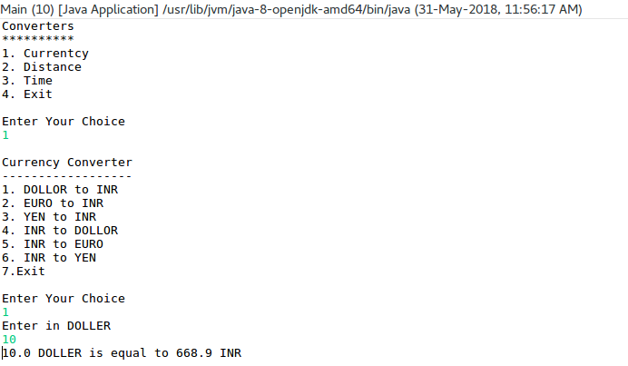
Distance
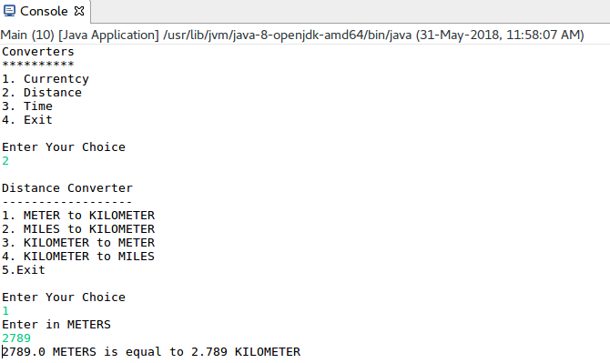

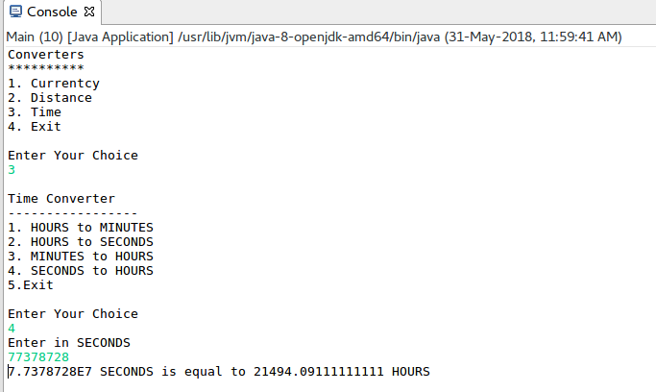
Min to Hours

Result

The java console application for converters [Currency, Distance, Time] was developed and tested successfully.

Ex.No: 3 | Employee Payroll System
Date: | Employee Payroll System

Aim:

To create a Java console application for employee payroll process management. This project includes Employee and they further classified as Programmer, Assistant Professor, Associate Professor, Professor.

Algorithm:

Step 1 | Start the process
Step 2 | Prompt the user with converter choice 1. Programmer 2. Assistant Professor 3. Associate Professor 4. Professor 5. Exit and get the choice.
Step 3 | If user selects a Programmer then proceed to step 4
Step 4 | Get the user details [Name, ID, Address, Mail ID and Mobile Number] and goto step 5
Step 5 | Proceed to Programmers Payment Processing
 | Step 5.1 | Get the basic pay of Programmer
 | Step 5.2 | If user enters -1 assume basic pay as 30000 and goto step 15
 | Step 5.3 | Else directly go to step 15
Step 6 | If user selects Assistant Professor step 7
Step 7 | Get the user details [Name, ID, Address, Mail ID and Mobile Number] and goto step 8
Step 8 | Proceed to Assistant Professor Payment Processing
 | Step 8.1 | Get the basic pay of Assistant Professor
 | Step 8.2 | If user enters -1 assume basic pay as 25000 and goto step 15
 | Step 8.3 | Else directly go to step 15
Step 9 | If user selects Associate Professor step 10
Step 10 | Get the user details [Name, ID, Address, Mail ID and Mobile Number] and goto step 11
Step 11 | Proceed to Associate Professor Payment Processing
 | Step 11.1 | Get the basic pay of Associate Professor
 | Step 11.2 | If user enters -1 assume basic pay as 40000 and goto step 15
 | Step 11.3 | Else directly go to step 15
Step 12 | If user selects Professor step 13
Step 13 | Get the user details [Name, ID, Address, Mail ID and Mobile Number] and goto step 14
Step 14 | Proceed to Professor Payment Processing
 | Step 14.1 | Get the basic pay of Professor
 | Step 14.2 | If user enters -1 assume basic pay as 70000 and goto step 15
 | Step 14.3 | Else directly go to step 15
Step 15 | Compute Per_Day_Pay = original_basic_pay / no_of_days_in_the_current_month
Step 16 | Get the number of days worked from user that include Cl, WH, FH and exclude the LOP
Step 17 | Check no_days_worked <= no_of_days_in_the_current_month. Else display “Error Message” and goto step 18
Step 18 | Compute Current_Basic_Pay = Per_Day_Pay * no_days_worked
Step 19 | Compute Following and Store  DA = (Current_Basic_Pay/100) * 97  HRA = (Current_Basic_Pay/100) * 12  PF = (Current_Basic_Pay/100) * 0.1  GROSS_PAY = Current_Basic_Pay + DA + HRA + PF  NET_PAY = GROSS_PAY - PF
Step 17 | Display Payment Details [Name, ID, Address, Mail ID, Mobile Number, BASIC PAY, DA, HRA,PF,GROSS_PAY, NET_PAY].
Step 18 | Stop Processing

Coding

Employee.java

package com.raja.oopslab.employee;
import java.util.Calendar;
import java.util.GregorianCalendar;
import java.util.Scanner;

package com.raja.oopslab.employee;

import java.util.Calendar;
import java.util.GregorianCalendar;
import java.util.Scanner;

class Employee {
String emp_name;
String emp_id;
String emp_address;
String emp_mail_id;
String emp_mobile_no;
int basic_pay;
int per_day_pay;
int current_basic_pay;
int da, hra, pf, gross_pay;
int net_pay;
int no_of_days_in_current_month;
int no_of_days_worked;
Calendar cal;
Scanner input;

Employee() {
input = new Scanner(System.in);
cal = new GregorianCalendar();
no_of_days_in_current_month = cal.getActualMaximum(Calendar.DAY_OF_MONTH);
getUserBasicDetails();
}

public void generatePaySlip() {
this.da = (this.current_basic_pay / 100) * 97;
this.hra = (this.current_basic_pay / 100) * 12;
this.pf = (int) ((this.current_basic_pay / 100) * 0.1);
this.gross_pay = this.current_basic_pay + da + hra + pf;
this.net_pay = gross_pay - pf;
}

public void displayPaySlip() {
System.out.println("Name: " + this.emp_name);
System.out.println("ID: " + this.emp_id);
System.out.println("Address: " + this.emp_address);
System.out.println("MailID: " + this.emp_mail_id);
System.out.println("Mobile No: " + this.emp_mobile_no);
System.out.println("\nEarnings");
System.out.println("--------");
System.out.println("BASIC Pay: " + current_basic_pay + " Rs");
System.out.println("DA : " + da + " Rs");
System.out.println("HRA : " + hra + " Rs");
System.out.println("\nDeductions");
System.out.println("----------");
System.out.println("PF : " + pf + " Rs");
System.out.println("GROSS Pay: " + gross_pay + " Rs");
System.out.println("NET Pay: " + net_pay + " Rs");
}

public void getUserBasicDetails() {
System.out.println("Enter Details");
System.out.println("Name: ");
this.emp_name = input.next();
System.out.println("ID: ");
this.emp_id = input.next();
System.out.println("Address: ");
this.emp_address = input.next();
System.out.println("MailID: ");
this.emp_mail_id = input.next();
System.out.println("Mobile No:");
this.emp_mobile_no = input.next();
}

public void computeCurrentBasicPay(String empType) {
this.per_day_pay = this.basic_pay / no_of_days_in_current_month;
System.out.println("\nBasic Pay of " + empType + " " + this.basic_pay + " for "
+ this.no_of_days_in_current_month + " days");
System.out.println("This month this " + empType + " gets " + this.per_day_pay + " INR as basic pay per day");
System.out.println("Enter no.of days worked by " + empType + " including CL, WH, FH and excluding LWP:");
this.no_of_days_worked = input.nextInt();
if (no_of_days_worked <= no_of_days_in_current_month) {
this.current_basic_pay = this.per_day_pay * no_of_days_worked;
System.out.println("Programmer");
System.out.println("----------");
generatePaySlip();
} else {
System.out.println("Sorry Please Enter Valid Days");
}
}

protected void finalize() {
input.close();
System.exit(0);
}
}

Programmer.java

package com.raja.oopslab.employee;

public class Programmer extends Employee {

public Programmer() {
super();
computeProgrammerPay();

}

public void computeProgrammerPay() {
System.out.println("Enter Basic pay of Programmer [enter -1 for Default [BP = 30000]]:");
this.basic_pay = input.nextInt();
if (this.basic_pay == -1) {
this.basic_pay = 30000;
System.out.println("Default Pay Taken");
}
computeCurrentBasicPay("Programmer");
generatePaySlip();
displayPaySlip();
}

}

Assistant Professor.java

package com.raja.oopslab.employee;

public class AssistantProfessor extends Employee {
public AssistantProfessor() {
super();
computeAssistantProfessorPay();
}

public void computeAssistantProfessorPay() {
System.out.println("Enter Basic pay of AssistantProfessor [enter -1 for Default [BP = 25000]]:");
this.basic_pay = input.nextInt();
if (this.basic_pay == -1) {
this.basic_pay = 25000;
System.out.println("Default Pay Taken");
}
computeCurrentBasicPay("AssistantProfessor");
generatePaySlip();
displayPaySlip();
}
}

Associate Professor

package com.raja.oopslab.employee;

public class AssociateProfessor extends Employee {
public AssociateProfessor() {
super();
computeAssociateProfessorPay();
}

public void computeAssociateProfessorPay() {
System.out.println("Enter Basic pay of AssociateProfessor [enter -1 for Default [BP = 40000]]:");
this.basic_pay = input.nextInt();
if (this.basic_pay == -1) {
this.basic_pay = 40000;
System.out.println("Default Pay Taken");
}

computeCurrentBasicPay("AssociateProfessor");
generatePaySlip();
displayPaySlip();
}
}

Professor

package com.raja.oopslab.employee;

public class Professor extends Employee {
public Professor() {
super();
computeProfessorPay();
}

public void computeProfessorPay() {
System.out.println("Enter Basic pay of Professor [enter -1 for Default [BP = 70000]]:");
this.basic_pay = input.nextInt();
if (this.basic_pay == -1) {
this.basic_pay = 70000;
System.out.println("Default Pay Taken");
}
computeCurrentBasicPay("Professor");
generatePaySlip();
displayPaySlip();
}
}
Main.java

import java.io.BufferedReader;
import java.io.IOException;
import java.io.InputStreamReader;
import java.util.Scanner;

import com.raja.oopslab.employee.AssistantProfessor;
import com.raja.oopslab.employee.AssociateProfessor;
import com.raja.oopslab.employee.Programmer;
import com.raja.oopslab.employee.Professor;

public class Main {

public static void main(String[] args) throws IOException {
Programmer aProgrammer;
AssistantProfessor aAssistantProfessor;
AssociateProfessor aAssociateProfessor;
Professor aProfessor;
String choice;
int n_choice = 0;
Scanner userInput = new Scanner("System.in");

while (n_choice != 5) {
System.out.println("\n\nEmployee Payroll System");
System.out.println("***********************\n");
System.out.println("1. Programmer\n2. Assistant Professor\n" + "3. Associate Professor\n4. Professor\n"
+ "5. Exit\n\nEnter Your Choice");
choice = new BufferedReader(new InputStreamReader(System.in)).readLine();
n_choice = Integer.parseInt(choice);
switch (n_choice) {
case 1:
System.out.println("Programmer Selected");
aProgrammer = new Programmer();
break;
case 2:
System.out.println("AssistantProfessor Selected");
aAssistantProfessor = new AssistantProfessor();
break;
case 3:
System.out.println("AssociateProfessor Selected");
aAssociateProfessor = new AssociateProfessor();
break;
case 4:
System.out.println("Professor Selected");
aProfessor = new Professor();
case 5:
System.out.println("Thank You !!!");
userInput.close();
break;
default:
System.out.println("Enter valid choice !!!");
break;
}
}
}}

Output:

Choices
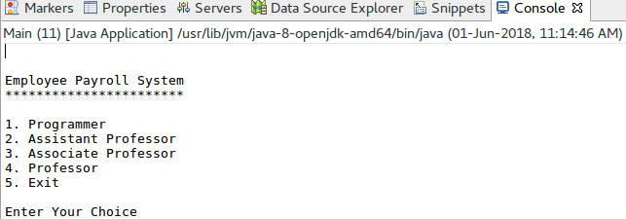

Basic Details

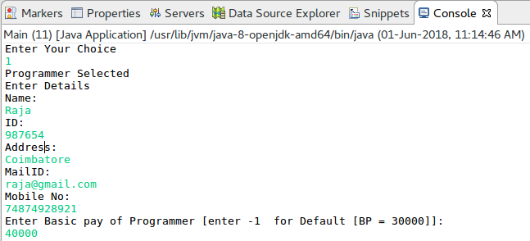

Programmer

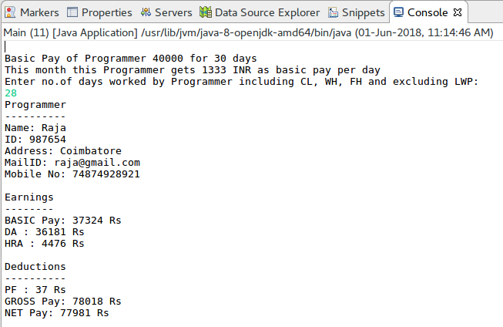
Assistant Professor

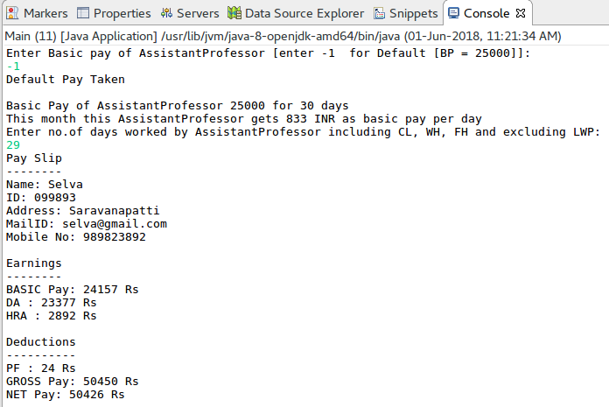
Associate Professor

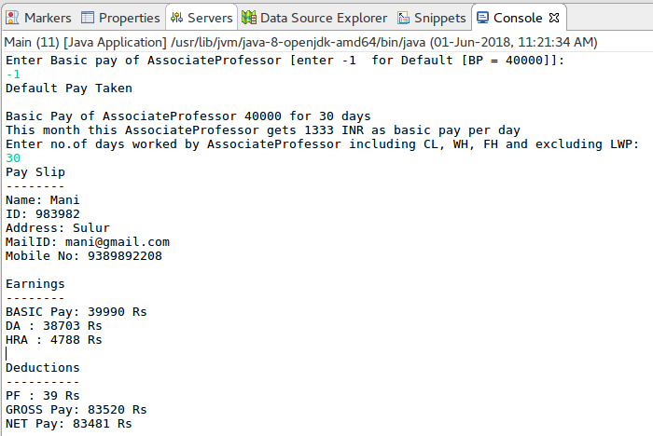
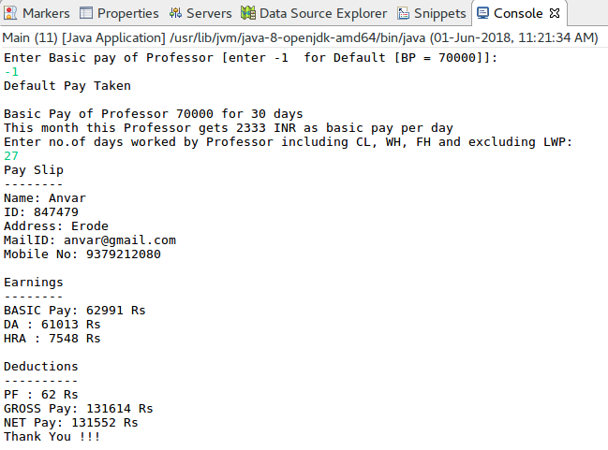
Professor

Result:

The java console application for employee payroll system was developed and tested successfully.

Ex.No: 4 | Java Application for ADT Stack using Interfaces
Date: | Java Application for ADT Stack using Interfaces

Aim:

To create a Java console application using interface concepts of java for abstract data type stack. Stack operations must be controlled by exception handling techniques.

Algorithm:

Step 1 | Start the process.
Step 2 | Get the Stack’s maximum limit from user.
Step 3 | Create an array with the limit and initialize all the elements as -1 and initialize current_position with 0
Step 4 | Prompt the user with choice for stack operations  1. PUSH 2.POP 3.PEEK 4.DISPLAY 5.EXIT
Step 5 | Get the choice from user and goto step 6
Step 6 | If user selects to PUSH
 | Step 6.1 | Get the number from user to push.
 | Step 6.2 | Try to assign the value to array assuming that array index is current position.
 | Step 6.3 | If exception rises display message “Stack is full try to pop someting” and goto step 9.
 | Step 6.4 | Else increment current position with the value 1 and display element pushed index and goto step 9.
Step 7 | If user selects to POP
 | Step 7.1 | Try to set previous position of current position to -1
 | Step 7.2 | If exception rises display message “Stack is empty try to push something” and goto step 9.
 | Step 7.3 | Else decrement current position with the value 1 and display popped element and goto step 9.
Step 8 | If user selects to PEEK display element display current_position -1 element in the array
Step 9 | If user selects to DISPLAY
 | Step 9.1 | Display array reversely and elements which is not equal to -1 and goto step 4
Step 10 | Exit from the process.
Step 11 | Stop the process.

Coding

StackOpeations.java [Interface]

package com.raja.oopslab.stackadt;

public interface StackOperations {

boolean push(int number);

boolean pop();

void peek();

void display();
}

CustomStack.java

package com.raja.oopslab.stackadt;

public class CustomStack implements StackOperations {
int[] stack_array;
int limit;
int current_position = 0;

public CustomStack(int limit) {
this.limit = limit;
stack_array = new int[limit];
initStack();
}

public void initStack() {
for (int i = 0; i < limit; i++)
stack_array[i] = -1;
}

@Override
public boolean push(int number) {

try {

stack_array[current_position] = number;
current_position++;
System.out.println("The element " + number + " pushed in the position " + current_position);
display();
return true;
}

catch (ArrayIndexOutOfBoundsException e) {
System.out.println("Sorry Stack Full Please do some POP's");
}
return false;

}

@Override
public boolean pop() {
int poped_element;
try {
poped_element = stack_array[current_position - 1];
stack_array[current_position - 1] = -1;
current_position--;
System.out.println("Poped element is : " + poped_element);
display();
return true;
} catch (ArrayIndexOutOfBoundsException e) {
System.out.println("Sorry Stack is Empty try to do some push");
}
return false;
}

@Override
public void display() {

System.out.println("\nStack Display");
System.out.println("*************\n");
for (int i = limit - 1; i >= 0; i--)
if (stack_array[i] != -1)
System.out.println(stack_array[i]);
System.out.println("\n*************");
}

@Override
public void peek() {
int peek_element = 0;
peek_element = stack_array[current_position - 1];
System.out.println("Peek Element of the Stack is " + peek_element);
}

}

Main.java

import java.util.Scanner;
import com.raja.oopslab.stackadt.*;

public class Main {
public static void main(String[] args) {
Scanner input = new Scanner(System.in);
System.out.print("Enter the size of stack :");
CustomStack mystack = new CustomStack(input.nextInt());
int choice = 0;
while (choice != 5) {
System.out.println("\n1.PUSH\n2.POP\n3.PEEK\n4.DISPLAY\n5.EXIT");
System.out.println("Please Enter Your Choice : ");
choice = input.nextInt();
switch (choice) {
case 1:
System.out.println("Enter the Element to PUSH : ");
mystack.push(input.nextInt());
break;
case 2:
mystack.pop();
break;
case 3:
mystack.peek();
break;
case 4:
mystack.display();
break;
case 5:
System.out.println("!!! Thank You !!!");
break;
}

}
input.close();
System.exit(0);
}

}
Output:

Choice:

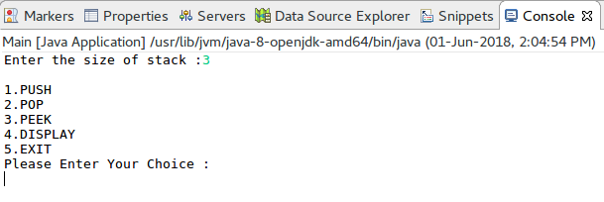
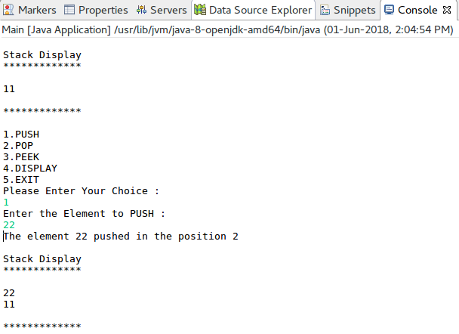
Push Operation:
Pop and Peek Operation:

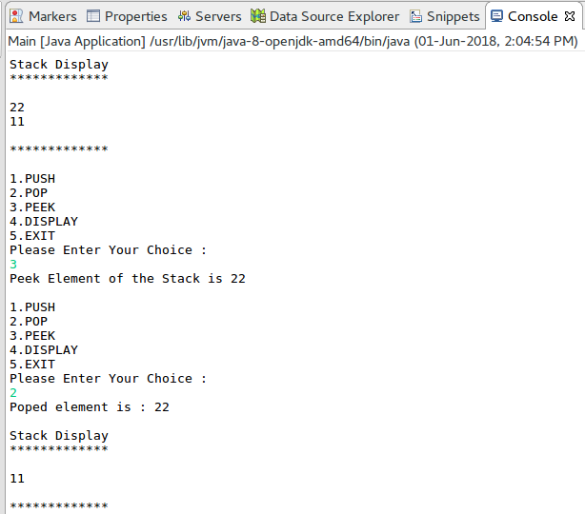

Stack Empty Error:
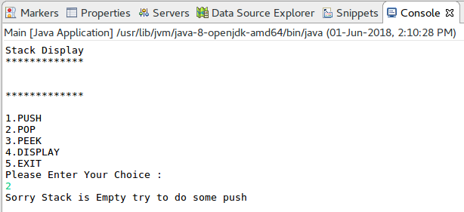
Stack Full Error:

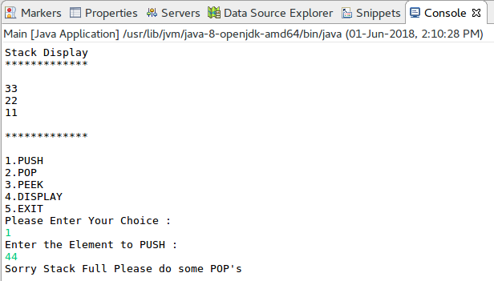

Result:

The java console application for abstract data type stack using java interface concepts is developed and tested successfully.

Ex.No: 5 | Java Application for String Operations using ArrayList
Date: | Java Application for String Operations using ArrayList

Aim:

To create a Java console application for string list operations [Append, Insert at particular Index, Search a string in a list, Display all the strings that begins with a character] using ArrayList in java.

Algorithm:

Step 1 | Start the Process
Step 2 | Prompt user with List Operation Choices  1. Append 2. Insert at particular Index 3. Search a string in a list  4. Display all the strings in a list 5. Display all the strings that begins with a character  6. Exit
Step 3 | If user selects option 1 then get the string from user and add at last position of the list.
Step 4 | If user selects option 2
 | Step 4.1 | Get the string and position from the user
 | Step 4.2 | Check the position exceeds from list size
 | Step 4.3 | If exceeds then prompt an error “Sorry Position is not in the list limit” and goto step 2.
 | Step 4.4 | Else create temporary list
 | Step 4.5 | Add all the elements of the list upto current position one by one.
 | Step 4.6 | Add current element to the list
 | Step 4.7 | Add remaining elements one by one.
 | Step 4.8 | Assign temporary list as source list and goto step 2
Step 5 | If user selects option 3 then get the string to be searched from the user.
 | Step 5.1 | Check every string one by one for string match
 | Step 5.2 | If match found and display the string and position and goto step 2
 | Step 5.3 | Else prompt an error message “String not found in the list” and goto step 2
Step 6 | If user selects option 4 the display all the strings one by one. After that goto step 2.
Step 7 | If user selects option 5 then proceed following
 | Step 7.1 | Get the character from user
 | Step 7.2 | Get all the string one by one and match first letter with character entered by the user
 | Step 7.3 | If character matches display the string
 | Step 7.4 | Else move to next string.
 | Step 7.5 | At the end goto step 2
Step 8 | If user selects option 6 exit from process and stop processing

Coding:

StringList.java

package com.raja.oopslab.stringlist;

import java.util.ArrayList;

public class StringList {
ArrayList<String> listOfStrings;

public StringList() {
listOfStrings = new ArrayList<String>();
}

public boolean addString(String aString) {
boolean result = listOfStrings.add(aString);
return result;
}

public void insertStringAt(int position, String aString) {
int list_size = listOfStrings.size();
int cur_pos = 0;
ArrayList<String> templist = new ArrayList<String>();
if (position > list_size)
System.out.println("Sorry Position is not in the list limit");
else {
for (String elememt : listOfStrings) {

if (cur_pos == position)
templist.add(aString);

templist.add(elememt);
cur_pos++;
}
}
listOfStrings = templist;
}

public void displayList() {
int i = 0;
for (String element : listOfStrings){
System.out.println(i+"."+element);
i++;
}
}

public void searchString(String aString) {

int cur_pos = 0;
int foundAt = -1;

for (String element : listOfStrings) {
if (element.equalsIgnoreCase(aString)) {
foundAt = cur_pos;
break;
} else
cur_pos++;
}
if (foundAt >= 0)
System.out.println("Your string " + aString + " found at position " + cur_pos);
else
System.out.println("String not found in the list");
}

public void displayStringsBeginWith(String aLetter) {
System.out.println("The String's Begins with Letter ["+aLetter+"]\n");
for (String element : listOfStrings) {
String firstLetter = String.valueOf(element.charAt(0));
if (aLetter.equals(firstLetter))
System.out.println(element);
}
}
}

Main.java

import java.io.BufferedReader;
import java.io.IOException;
import java.io.InputStream;
import java.io.InputStreamReader;
import java.util.Scanner;

import com.raja.oopslab.stringlist.StringList;

public class Main {
public static void main(String[] args) {
StringList stringList = new StringList();
Scanner userInput = new Scanner(System.in);
String aString = null;
int choice = 0;
int position = 0;
while (choice != 6) {
System.out.println("\nString List Operations");
System.out.println("************************");
System.out.println(
"1. Append a String\n"
+ "2. Insert a String at Position\n"
+ "3. Search a String\n"
+ "4. List all Strings\n"
+ "5. Display String's Begins with a Letter\n"
+ "6.Exit");

choice = userInput.nextInt();

switch (choice) {
case 1:
System.out.println("Enter a String: ");
stringList.addString(userInput.next());
break;
case 2:
System.out.println("Enter a String: ");
aString = userInput.next();
System.out.println("Enter a Position to Insert: ");
position = userInput.nextInt();
stringList.insertStringAt(position, aString);
break;
case 3:
System.out.println("Enter a String to Be Searched: ");
aString = userInput.next();
stringList.searchString(aString);
break;
case 4:
System.out.println("\nList Contains");
System.out.println("-------------");
stringList.displayList();
break;
case 5:
System.out.println("Enter a letter");
stringList.displayStringsBeginWith(userInput.next());
break;
case 6:
System.out.println("\n\nThank You !!!");
userInput.close();
System.exit(0);
break;
default:
System.out.println("Please enter valid input");
break;
}
}
}
}

Output:

List Choices:

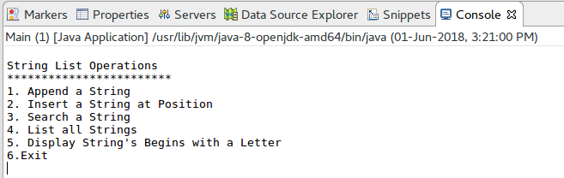

Append a string:

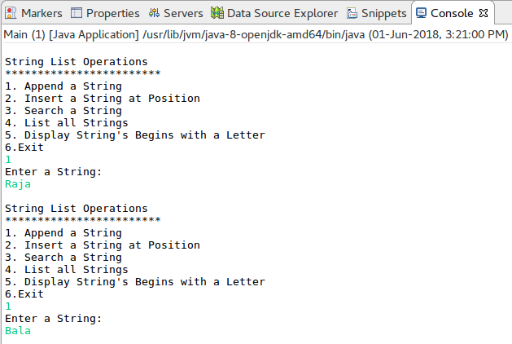
Display List:

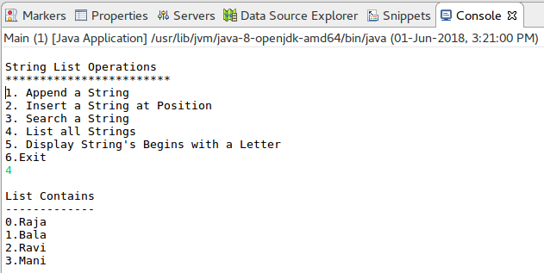
Insert At Position:

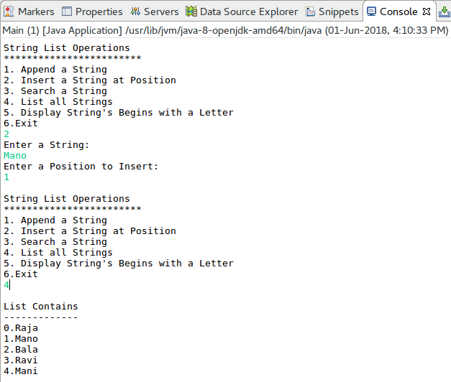

Search a String:

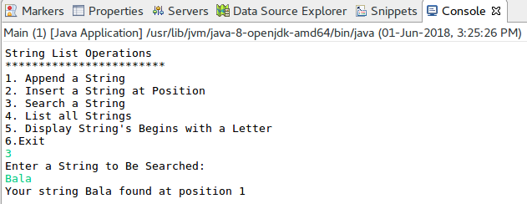
List the string’s that begins with a letter “R”:

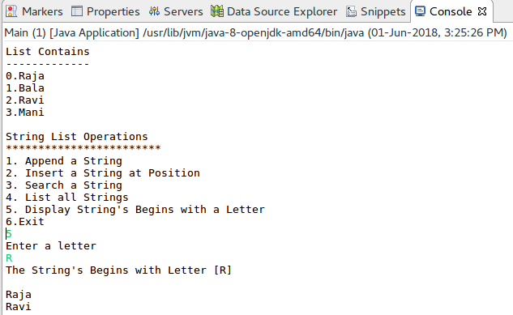

Result:

The java console application for string list operations was developed and tested successfully.

Ex.No: 6 | Java Application to Find the Area of different Shapes
Date: | Java Application to Find the Area of different Shapes

Aim:

To create a Java console application to find the area of different shapes using abstract class concept in java.

Algorithm:

Step 1 | Start the Process
Step 2 | Prompt user with List Operation Choices  1. Rectangle 2. Triangle 3. Circle 4, Exit  Get the choice from user.
Step 3 | If user selects Rectangle
 | Step 3.1 | Get the Length and Breath from the user
 | Step 3.2 | Compute Area = Length * Breath
 | Step 3.3 | Display Area
Step 4 | If user selects Triangle
 | Step 3.1 | Get the Length and Height from the user
 | Step 3.2 | Compute Area = Length * Height * 0.5
 | Step 3.3 | Display Area
Step 5 | If user selects Circle
 | Step 5.1 | Get the Radius of the Circle
 | Step 5.2 | Compute Area = 3.14 * Radius * Radius
 | Step 5.3 | Display Area
Step 6 | If user selects exit end the process
Step 7 | Stop the Process

Coding:

Shape.java

package com.raja.oopslanb.shapes;

public abstract class Shape {
double length = 0.0;
double hight = 0.0;
public abstract void printArea();
}

Rectangle.java

package com.raja.oopslanb.shapes;

import java.util.Scanner;

public class Rectangle extends Shape {
double area = 0.0;

@Override
public void printArea() {
System.out.println("\nRectangle");
System.out.println("---------\n");
Scanner input = new Scanner(System.in);
System.out.println("Enter Length of Rectangle : ");
this.length = input.nextDouble();
System.out.println("Enter Breadth of Rectangle : ");
this.hight = input.nextDouble();
this.area = this.length * this.hight;
System.out.println("Area of the Rectangle is : " + this.area);
}

}

Triangle.java

package com.raja.oopslanb.shapes;

import java.util.Scanner;

public class Triangle extends Shape {
double area = 0.0;

@Override
public void printArea() {
System.out.println("\nTriangle");
System.out.println("---------\n");
Scanner input = new Scanner(System.in);
System.out.println("Enter Length of Triangle : ");
this.length = input.nextDouble();
System.out.println("Enter Hight of Triangle : ");
this.hight = input.nextDouble();
this.area = 0.5 * this.length * this.hight;
System.out.println("Area of the Triangle is : " + this.area);
}

}

Circle.java

package com.raja.oopslanb.shapes;

import java.util.Scanner;

public class Circle extends Shape {
double area = 0.0;

@Override
public void printArea() {
System.out.println("\nCircle");
System.out.println("-------\n");
Scanner input = new Scanner(System.in);
System.out.println("Enter Radius of Circle : ");
this.length = input.nextDouble();
this.area = Math.PI * this.length * this.length;
System.out.println("Area of the Circle is : " + this.area);
}

}

Main.java

import com.raja.oopslanb.shapes.Rectangle;
import com.raja.oopslanb.shapes.Shape;
import com.raja.oopslanb.shapes.Triangle;

import java.util.Scanner;

import com.raja.oopslanb.shapes.Circle;

public class Main {
public static void main(String[] args) {
Scanner userInput = new Scanner(System.in);
int choice = 0;
do {
System.out.println("Finding Area");
System.out.println("************");
System.out.println(
"\n1. Rectangle" + "\n2. Triangle" + "\n3. Circle" + "\n4. Exit" + "\n\nEnter your choice: ");
choice = userInput.nextInt();
switch (choice) {
case 1:
Shape rt = new Rectangle();
rt.printArea();
break;
case 2:
Shape tr = new Triangle();
tr.printArea();
break;
case 3:
Shape cr = new Circle();
cr.printArea();
break;
case 4:
System.out.println("\n\nThank You !!!");
userInput.close();
break;
default:
System.out.println("Please enter valid input");
break;
}
} while (choice != 4);
}
}

Output:

Choice

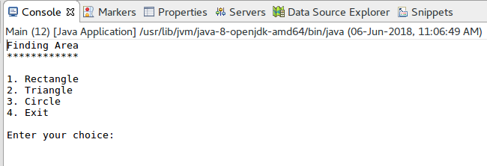
Rectangle

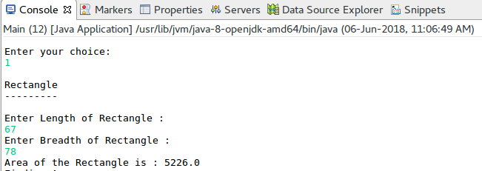

Triangle

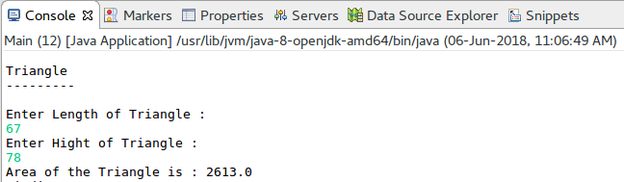

Circle

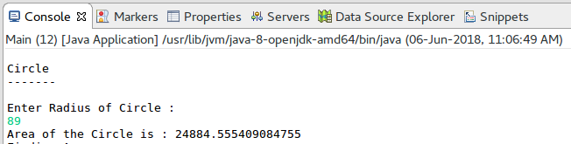

Result:

The Java console application to find the area of different shapes using abstract class concept in java was developed and tested successfully.

Ex.No: 7 | Bank Transaction System with User Exceptions
Date: | Bank Transaction System with User Exceptions

Aim:

To create a Java console application for Banking transaction system that helps the users to do their credit and debit transactions and it rises user defined exception while encountering errors in transaction and also it should be solved using exception handling techniques.

Algorithm:

Step 1 | Start the Process
Step 2 | Prompt user with List Operation Choices  1. Add Money 2. Get Money 3. Details 4. Exit  Get the choice from user.
Step 3 | If user selects Add Money
 | Step 3.1 | Get the amount to be added to balance from the user
 | Step 3.2 | If the amount is less than 0 then throw Invalid Credit Exception and goto step 3.4
 | Step 3.3 | Else add amount to balance and goto step 2
 | Step 3.4 | Prompt user with “Enter valid credit amount” and goto step 3.1
Step 4 | If user selects Get Money
 | Step 4.1 | Get the amount to be debited to balance from the user
 | Step 4.2 | If the amount is greater than existing balance then throw Invalid Debit Exception and goto step 4.4
 | Step 4.3 | Else deduct amount from balance and goto step 2
 | Step 4.4 | Prompt user with “Enter valid debit amount” and goto step 4.1
Step 5 | If user selects Details then display Customer Details [Name, Account Number, Current Balance]
Step 6 | If user wants to exit display “Thank You !!!” and end process
Step 7 | Stop the Process

Coding:

Customer.java

package com.raja.oopslab.exception.bank;

import java.util.Scanner;

public class Customer {
String name;
int accNo;
int balance;

public Customer(String name, int accNo) {
this.name = name;
this.accNo = accNo;
this.balance = 0;
}

public void creditTransaction(int amount) {
Scanner input = new Scanner(System.in);
try {
if (amount < 0)
throw new InvalidCredit();

else
balance = balance + amount;
} catch (InvalidCredit e) {
amount = input.nextInt();
creditTransaction(amount);
}

}

public void debitTransaction(int amount) {
Scanner input = new Scanner(System.in);
try {
if (amount > balance)
throw new InvalidDebit();

else
balance = balance - amount;
} catch (InvalidDebit e) {
amount = input.nextInt();
debitTransaction(amount);
}

}

public void displayDetails(){
System.out.println("Customer Details");
System.out.println("****************");
System.out.println("Customer Name : "+this.name);
System.out.println("Customer AccNo : "+this.accNo);
System.out.println("Customer Current Balance : "+this.balance);
}

}

InvalidCredit.java

package com.raja.oopslab.exception.bank;

public class InvalidCredit extends Exception {
public InvalidCredit() {
System.out.print("Please enter valid credit amount");
}
}

InvalidDebit.java

package com.raja.oopslab.exception.bank;

public class InvalidDebit extends Exception {
public InvalidDebit() {
System.out.print("Please enter valid debit amount");
}
}

Main.java

import java.util.Scanner;
import com.raja.oopslab.exception.bank.*;
public class Main {
public static void main(String[] args) {
Scanner input = new Scanner(System.in);
String name;
int acc_no;
System.out.println("Enter Customer Name");
name = input.next();
System.out.println("Enter account number");
acc_no = input.nextInt();
Customer aCustomer = new Customer(name, acc_no);
int choice = 0;
while(choice != 4){
System.out.println("\n1. Add Money\n2. Get Money\n3. Details\n4. Exit");
choice = input.nextInt();
switch(choice){
case 1:
System.out.println("Enter the amount");
aCustomer.creditTransaction(input.nextInt());
break;
case 2:
System.out.println("Enter the amount");
aCustomer.debitTransaction(input.nextInt());
break;
case 3:
aCustomer.displayDetails();
break;
case 4:
System.out.println("Thank You !!!");
break;
}
}
}
}

Output:

Choice:

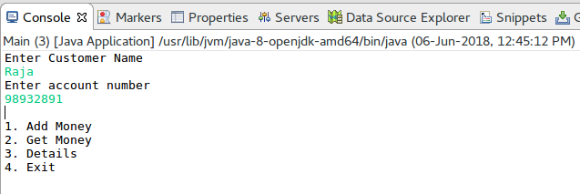
Display Details:

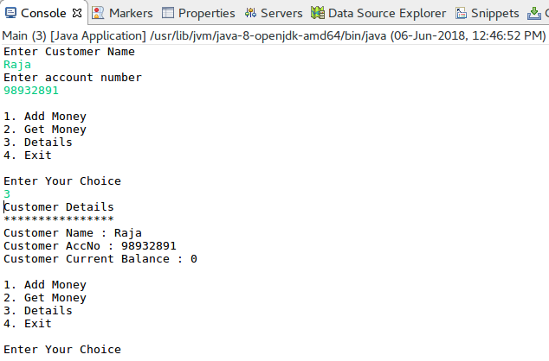
Add Money:

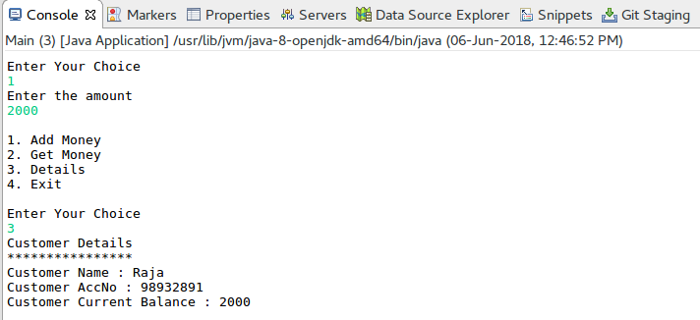

Get Money:

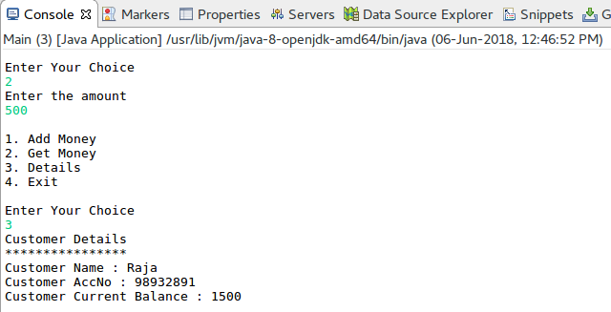
Exception in Add Money:

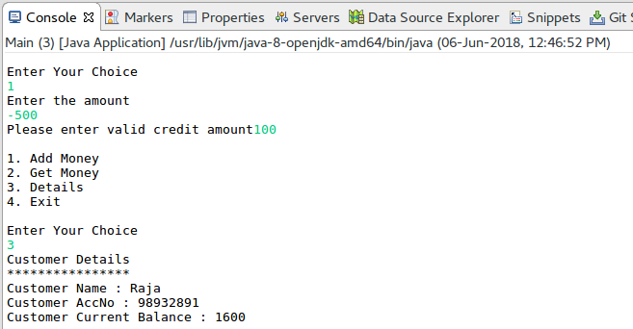

Exception in Get Money:

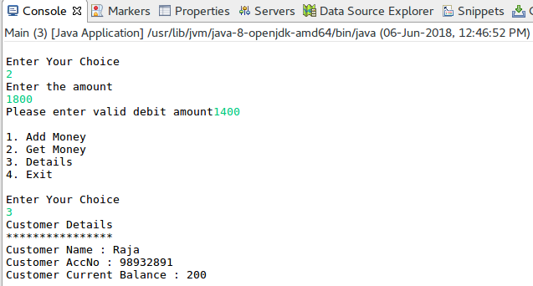

Result:

The java console application that uses user defined exception handling techniques was developed and tested successfully.

Ex.No: 8 | Java Application for File Handling
Date: | Java Application for File Handling

Aim:

To create a Java console application to handle the files and find the file properties [Availability, Readable or Writeable or Both, Length of the File].

Algorithm:

Step 1 | Start the Process
Step 2 | Prompt the user to enter the file name with path
Step 3 | Get the file name
 | Step 3.1 | Check the file is exits
 | Step 3.2 | If file exists then proceed to step 3.3 else proceed to step 3.8
 | Step 3.3 | Check the File is Both Readable and Writeable
 | Step 3.4 | If yes display file is “Read and Writeable”
 | Step 3.5 | Else check is readable if yes display “Read Only” else move to step 3.6
 | Step 3.6 | Else check is writeable if yes display “Write Only”
 | Step 3.7 | Compute file size and display
 | Step 3.8 | If file not existing then display “File Not Found”
Step 4 | Stop the Process

Coding:

UserFileHandler.java

package com.raja.oopslab.files;

import java.io.File;
public class UserFileHandler{
File aFile;
boolean isReadable = false;
boolean isWriteable = false;
boolean isExists = false;
int length = 0;
public UserFileHandler(String path) {
aFile = new File(path);
this.isExists = aFile.exists();
this.isReadable = aFile.canRead();
this.isWriteable = aFile.canWrite();
this.length = (int) aFile.length();
}
public void fileDetails(){
if(isExists){
System.out.println("The File "+aFile.getName()+" is Available at:"+aFile.getParent());
if(isReadable && isWriteable)
System.out.println("File is Readable and Writeable");
else if(isReadable)
System.out.println("File is Only Readable");
else if(isWriteable)
System.out.println("File is Only Writeable");
System.out.println("Total length of the file is :"+this.length+" bytes");
}
else
System.out.println("File does not exists ");
}
}

Main.java

import java.io.File;
import java.util.Scanner;
import com.raja.oopslab.files.*;
public class Main {

public static void main(String[] args) {
String file_path = null;
Scanner input = new Scanner(System.in);
System.out.println("File Handler");
System.out.println("************");
System.out.println("Enter the file path");
file_path = input.next();
new UserFileHandler(file_path).fileDetails();
}
}

Output:

Availability of File:

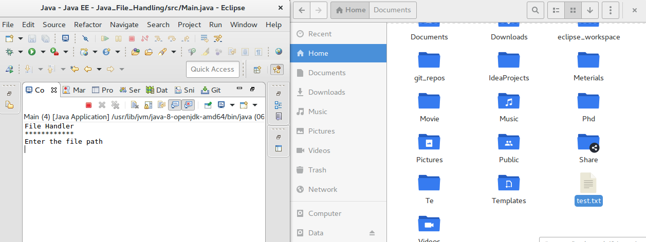

File Read and Writeable:

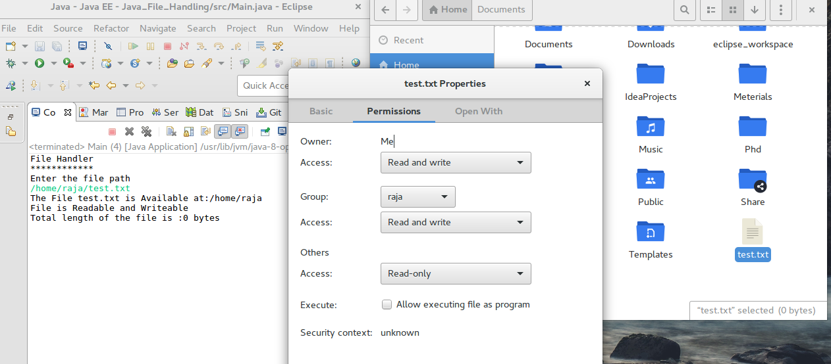

File Size:

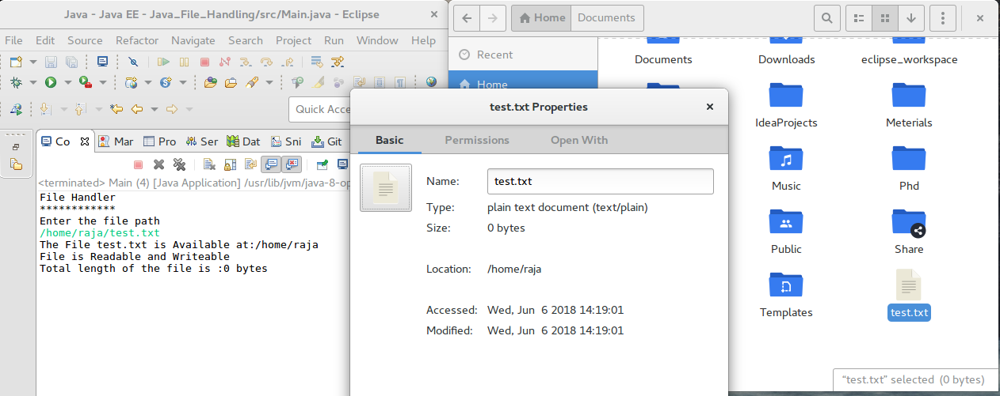

File Not Exists:

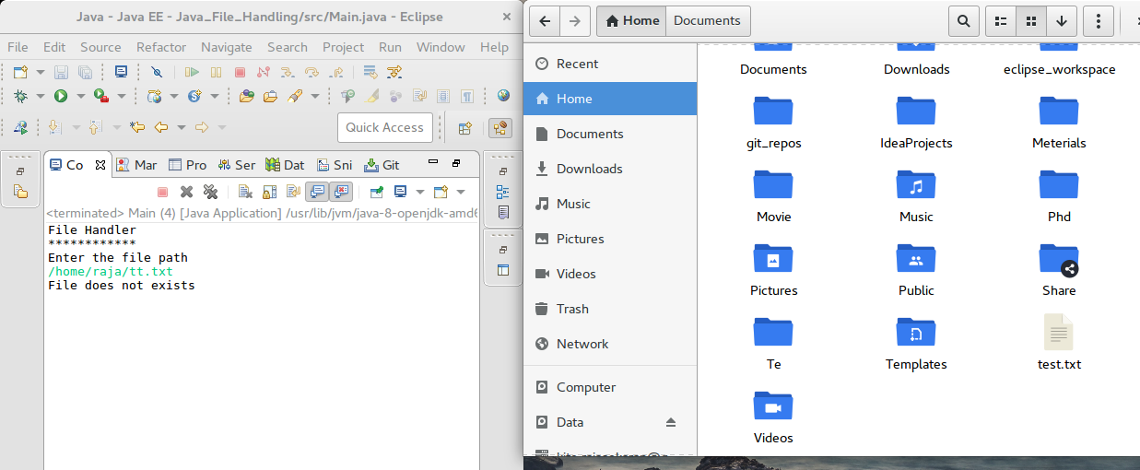

Result:

The java console application for handling files was developed and tested successfully.

Ex.No: 9 | Java Application for Multi threading
Date: | Java Application for Multi threading

Aim:

To create a Java console application the uses the multi threading concepts in java. The Application has 3 threads one creates random number, one thread computes square of that number and another one computes the cube of that number.

Algorithm:

Step 1 | Start the Process
Step 2 | Create a thread that generates random number
Step 3 | Obtain one random number and check is odd or even
 | Step 3.1 | If number is even then create and start thread that computes square of a number
 | Step 3.2 | Compute number * number and display the answer
 | Step 3.3 | Notify to Random number thread and goto step 4
 | Step 3.4 | If number is odd then create and start thread that computes cube of a number
 | Step 3.4 | Compute number * number * number and display the answer
 | Step 3.5 | Notify to Random number thread and goto step 4
Step 4 | Wait for 1 Second and Continue to Step 3 until user wants to exits.
Step 5 | Stop the Process

Coding:

RandomNumberThread.java

package com.raja.oopslab.threading;

import java.util.Random;

public class RandomNumberThread extends Thread{
Random num = new Random();
int value;
@Override
public void run(){
while(true){
try {
this.sleep(1000);
} catch (InterruptedException e) {

}
value = num.nextInt(1000);
System.out.println("RandomNumberThread generated a number "+value);
if(value % 2 == 0)
new SquareGenThread(value).start();
else
new CubeGenThread(value).start();
}

}
}

SquareGenThread.java

package com.raja.oopslab.threading;

public class SquareGenThread extends Thread{
int number;
int squre;
public SquareGenThread(int number) {
this.number = number;
}
@Override
public void run(){
try {
this.sleep(3000);
} catch (InterruptedException e) {

}
this.squre = this.number * this.number;
System.out.println("SquareGenThread--> Square of "+number+" is "+squre);
}
}

CubeGenThread.java

package com.raja.oopslab.threading;

public class CubeGenThread extends Thread{
int number;
int squre;
public CubeGenThread(int number) {
this.number = number;
}
@Override
public void run(){
try {
this.sleep(2000);
} catch (InterruptedException e) {

}
this.squre = this.number * this.number * this.number;
System.out.println("CubeGenThread--> Square of "+number+" is "+squre);
}
}

Main.java

import java.util.Random;
import com.raja.oopslab.threading.RandomNumberThread;
public class Main {
public static void main(String[] args) {
new RandomNumberThread().start();
}
}

Output:

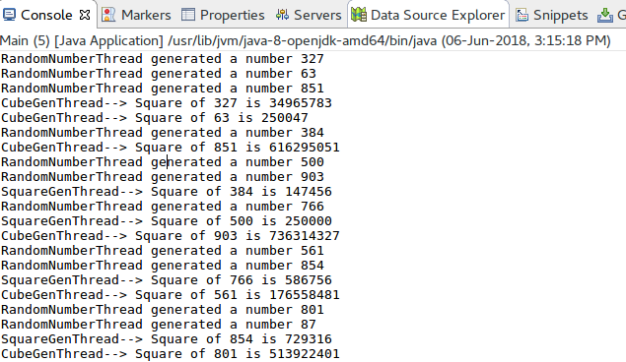

Result:

The java console application for multithreading was developed and tested successfully.

Ex.No: 10 | Java Application for Generic Max Finder
Date: | Java Application for Generic Max Finder

Aim:

To create a Java console application that finds the maximum in a array based on the type of the elements using generic functions in java.

Algorithm:

Step 1 | Start the Process
Step 2 | Create a array of number and array of strings and pass it to generic function.
Step 3 | If the array is Integer type
 | Step 3.1 | Assume first element as MAX
 | Step 3.2 | Compare [Numeric Perspetive] this element with MAX
 | Step 3.3 | If it is greater than MAX then store current element as MAX
 | Step 3.4 | Else do nothing
 | Step 3.5 | Goto step 3.1 until all the elements has been processed.
Step 4 | If the array is String type
 | Step 4.1 | Assume first element as MAX
 | Step 4.2 | Compare [Dictionary Perspective] this element with MAX
 | Step 4.3 | If it is greater than MAX then store current element as MAX
 | Step 4.4 | Else do nothing
 | Step 4.5 | Goto step 3.1 until all the elements has been processed.
Step 5 | Stop the Process

Coding:

class GenericMax {
public <T extends Comparable<T>> void maxFinder (T[] array){
T max = array[0];
for(T element: array){
System.out.println(element);
if(element.compareTo(max) > 0)
max = element;
}
System.out.println("Max is : "+max);
}
}

public class Main {

public static void main(String[] args) {
GenericMax max = new GenericMax();
Integer[] numbers = {14,3,42,5,6,10};
String[] strings = {"R","Ra","Raj"};
max.maxFinder(numbers);
max.maxFinder(strings);
}

}

Output:

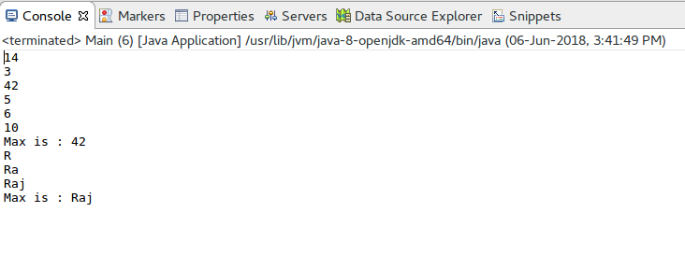

Result:

The java console application for finding generic max of given elements was developed and tested successfully.

Ex.No: 11 | Calculator Application using java AWT packages
Date: | Calculator Application using java AWT packages

Aim:

To create a Java GUI application that mimics the basic and advanced functionalities of a scientific calculator.

Algorithm:

Step 1 | Start the Process
Step 2 | Display Text View and Number Pad and Option Pads
Step 3 | If user presses any number get the existing numbers in Text View add them up and display
Step 4 | If user press Operators
 | Step 4.1 | Get the Text View content as Operant 1 and Set the display to null.
 | Step 4.2 | If user pressed “+” button set operator as plus
 | Step 4.3 | If user pressed “-” button set operator as minus
 | Step 4.4 | If user pressed “x” button set operator as multiply
 | Step 4.5 | If user pressed “/” button set operator as divide
 | Step 4.6 | Goto step 3
Step 5 | If user pressed “=” button then proceed following steps.
 | Step 5.1 | Get the Text View content as Operant 2 and Set the display to null.
 | Step 5.2 | If operator is “plus” then display Text View as Operant 1 + Operant 2
 | Step 5.3 | If operator is “minus” then display Text View as Operant 1 - Operant 2
 | Step 5.4 | If operator is “multiply” then display Text View as Operant 1 * Operant 2
 | Step 5.5 | If operator is “divide” then display Text View as Operant 1 / Operant 2
 | Step 5.6 | Goto step 4
Step 6 | If advanced button pressed
 | Step 6.1 | Change Operant Types [+,-,x,/ into sin, cos, tan, log] and goto step 2
Step 7 | If user pressed any of the operator
 | Step 7.1 | Get the Text View content as Operant 1 and Set the display to null.
 | Step 7.2 | If user pressed “sin” button set display the sin value of Operant 1
 | Step 7.3 | If user pressed “cos” button set display the cos value of Operant 1
 | Step 7.4 | If user pressed “tan” button set display the tan value of Operant 1
 | Step 7.5 | If user pressed “log” button set display the log value of Operant 1
 | Step 7.6 | Goto step 7
Step 8 | If advanced pressed again then revert the button changes and return back to normal
Step 9 | Repeat the process until user presses the close button then Stop the Process.

Coding:

import java.awt.BorderLayout;
import java.awt.Button;
import java.awt.Font;
import java.awt.Frame;
import java.awt.GridLayout;
import java.awt.Panel;
import java.awt.TextField;
import java.awt.event.ActionEvent;
import java.awt.event.ActionListener;
import java.awt.event.WindowAdapter;
import java.awt.event.WindowEvent;
import java.awt.event.WindowListener;

class Numpan extends Panel implements ActionListener{

Button n0,n1,n2,n3,n4,n5,n6,n7,n8,n9,point,equal;
Button plus,minus,multiply, divide;
Button m_plus,m_minus,clear,advanced;
TextField display;
String op1,op2,result;
String op_flag;
String data;
double dop1,dop2,dresult;
boolean flag_advanced=true;
public Numpan(TextField display) {
this.display = display;
setLayout(new GridLayout(0,4));

n0 = new Button("0");
n0.setActionCommand("zero");
n0.addActionListener(this);

n1 = new Button("1");
n1.setActionCommand("one");
n1.addActionListener(this);

n2 = new Button("2");
n2.setActionCommand("two");
n2.addActionListener(this);

n3 = new Button("3");
n3.setActionCommand("three");
n3.addActionListener(this);

n4 = new Button("4");
n4.setActionCommand("four");
n4.addActionListener(this);

n5 = new Button("5");
n5.setActionCommand("five");
n5.addActionListener(this);

n6 = new Button("6");
n6.setActionCommand("six");
n6.addActionListener(this);

n7 = new Button("7");
n7.setActionCommand("seven");
n7.addActionListener(this);

n8 = new Button("8");
n8.setActionCommand("eight");
n8.addActionListener(this);

n9 = new Button("9");
n9.setActionCommand("nine");
n9.addActionListener(this);

point = new Button(".");
point.setActionCommand("point");
point.addActionListener(this);

equal = new Button("=");
equal.setActionCommand("equal");
equal.addActionListener(this);

plus = new Button("+");
plus.setActionCommand("plus");
plus.addActionListener(this);

minus = new Button("-");
minus.setActionCommand("minus");
minus.addActionListener(this);

multiply = new Button("x");
multiply.setActionCommand("multiply");
multiply.addActionListener(this);

divide = new Button("/");
divide.setActionCommand("divide");
divide.addActionListener(this);

m_plus = new Button("M+");
m_plus.setActionCommand("m_plus");
m_plus.addActionListener(this);

m_minus = new Button("M-");
m_minus.setActionCommand("m_minus");
m_minus.addActionListener(this);

clear = new Button("C");
clear.setActionCommand("clear");
clear.addActionListener(this);

advanced = new Button("ADV");
advanced.setActionCommand("advanced");
advanced.addActionListener(this);

add(m_plus);
add(m_minus);
add(clear);
add(advanced);
add(n1);
add(n2);
add(n3);
add(plus);
add(n4);
add(n5);
add(n6);
add(minus);
add(n7);
add(n8);
add(n9);
add(multiply);
add(point);
add(n0);
add(equal);
add(divide);
}
public String getDisplayText(){
return display.getText().toString();
}
public void setDisplay(String text){
display.setText(text);
}
public void clearDisplay(){
System.out.println("Clear Called");
setDisplay("");
data = "";
}

public void changeAdvanced(boolean toAdvanced){
if(toAdvanced){
plus.setLabel("sin");
plus.setActionCommand("sin");
//System.out.println("cos in");
minus.setLabel("cos");
minus.setActionCommand("cos");
//System.out.println("cos out");
multiply.setLabel("tan");
multiply.setActionCommand("tan");
divide.setLabel("log");
divide.setActionCommand("log");

}
else{
plus.setLabel("+");
plus.setActionCommand("plus");
minus.setLabel("-");
minus.setActionCommand("minus");
multiply.setLabel("x");
multiply.setActionCommand("multiply");
divide.setLabel("/");
divide.setActionCommand("divide");
}
}
@Override
public void actionPerformed(ActionEvent e) {

data = getDisplayText();

switch(e.getActionCommand()){
case "zero":
setDisplay(data+"0");
break;
case "one":
setDisplay(data+"1");
break;
case "two":
setDisplay(data+"2");
break;
case "three":
setDisplay(data+"3");
break;
case "four":
setDisplay(data+"4");
break;
case "five":
setDisplay(data+"5");
break;
case "six":
setDisplay(data+"6");
break;
case "seven":
setDisplay(data+"7");
break;
case "eight":
setDisplay(data+"8");
break;
case "nine":
setDisplay(data+"9");
break;

case "plus":
op1 = data;
op_flag = "plus";
clearDisplay();
break;
case "minus":
op1 = data;
op_flag = "minus";
clearDisplay();
break;
case "multiply":
op1 = data;
op_flag = "multiply";
clearDisplay();
break;
case "divide":
op1 = data;
op_flag = "divide";
clearDisplay();
break;
case "clear":
clearDisplay();
break;
case "advanced":
if(flag_advanced){
changeAdvanced(true);
flag_advanced = false;
}
else{
changeAdvanced(false);
flag_advanced = true;
}
break;

case "sin":
op1 = data;
setDisplay(String.valueOf(Math.sin(Double.valueOf(op1))));
break;
case "cos":
op1 = data;
setDisplay(String.valueOf(Math.cos(Double.valueOf(op1))));
break;
case "tan":
op1 = data;
setDisplay(String.valueOf(Math.tan(Double.valueOf(op1))));
break;
case "log":
op1 = data;
setDisplay(String.valueOf(Math.log(Double.valueOf(op1))));
break;
case "equal":
switch(op_flag){
case "plus":
op2 = data;
clearDisplay();
dop1 = Double.parseDouble(op1);
dop2 = Double.parseDouble(op2);
dresult = dop1 + dop2;
result = String.valueOf(dresult);
setDisplay(result);
op_flag = "";
break;
case "minus":
op2 = data;
clearDisplay();
dop1 = Double.parseDouble(op1);
dop2 = Double.parseDouble(op2);
dresult = dop1 - dop2;
result = String.valueOf(dresult);
setDisplay(result);
op_flag = "";
break;

case "multiply":
op2 = data;
clearDisplay();
dop1 = Double.parseDouble(op1);
dop2 = Double.parseDouble(op2);
dresult = dop1 * dop2;
result = String.valueOf(dresult);
setDisplay(result);
op_flag = "";
break;

case "divide":
op2 = data;
clearDisplay();
dop1 = Double.parseDouble(op1);
dop2 = Double.parseDouble(op2);
dresult = dop1 / dop2;
result = String.valueOf(dresult);
setDisplay(result);
op_flag = "";
break;

}
}
}
}

class Calculator extends Frame {
TextField display;
public Calculator() {
display = new TextField();
display.setFont(new Font("Times New Roman", Font.BOLD, 50));
setLayout(new BorderLayout());
add(new Numpan(display),BorderLayout.CENTER);
add(display,BorderLayout.NORTH);
setVisible(true);
setSize(500,500);
addWindowListener(new WindowAdapter() {
@Override
public void windowClosing(WindowEvent e) {
dispose();
}
});
}

}
public class Main {

public static void main(String[] args) {
new Calculator();
}

}
Output:

Calculator:

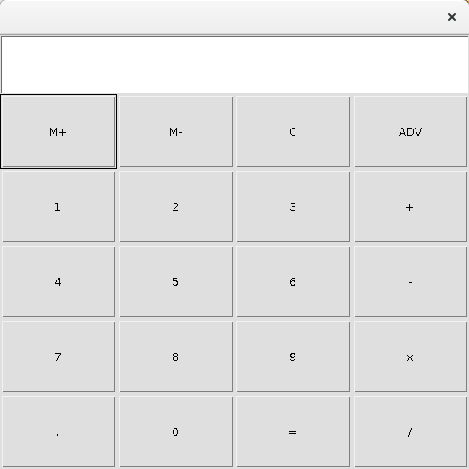

Basic Operations

Addition [12 + 12]

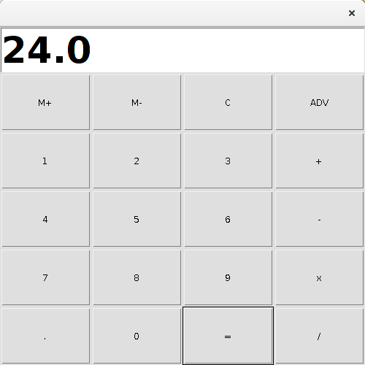

Subtraction [90 – 32]:

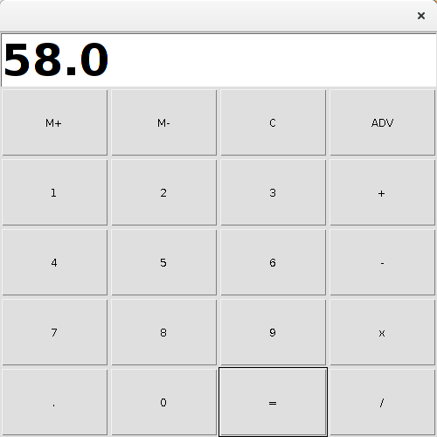
Multiplication [36 X 2]

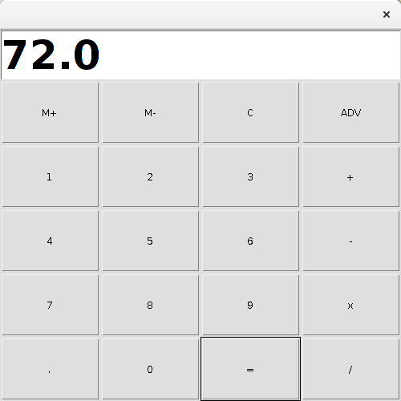
Division [45 / 2]

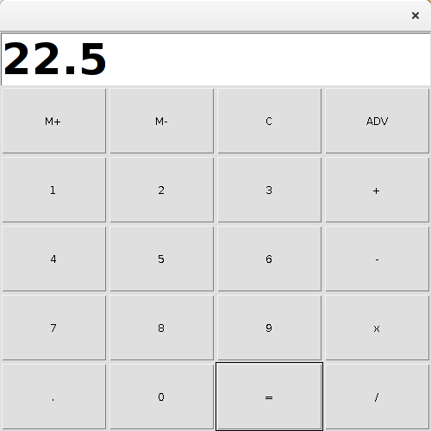
Scientific Operations:

Sin 30

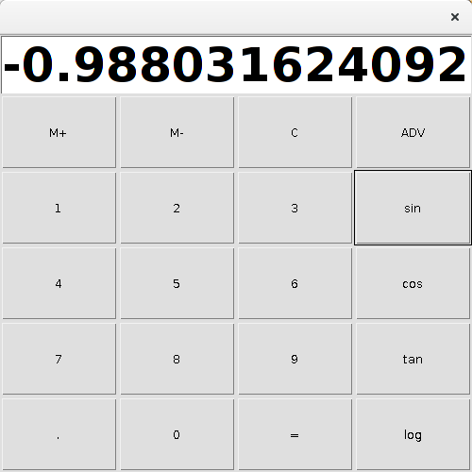
Cos 40:

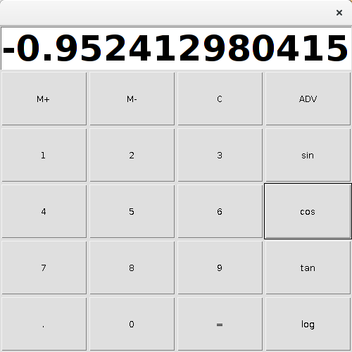

Tan 23

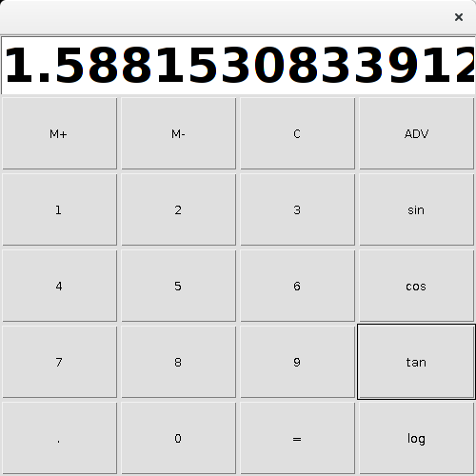
Log 60

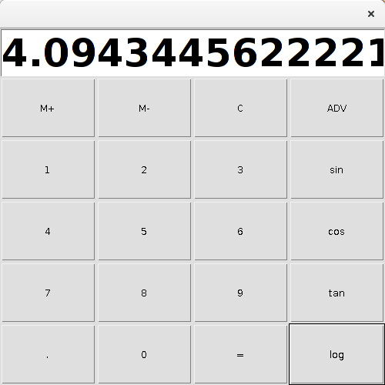

Result:

The java GUI application for calculator with basic and advanced functionalities was developed and tested successfully.

Important Links
S No | Experiment | Source | Demo
1 | Electricity Bill Calculator | https://github.com/rajasekaranap/CS8383_Java_EB_Bill_Calculator | https://youtu.be/1uSOIZDz-AA
2 | Unit Converters Application using packages | https://github.com/rajasekaranap/CS8383_Java_Converters | https://youtu.be/8HBADevR56M
3 | Employee Payroll System | https://github.com/rajasekaranap/CS8383_Java_Employee_Payroll | https://youtu.be/8KuDnx8hxxQ
4 | Java Application for ADT Stack using Interfaces | https://github.com/rajasekaranap/CS8383_Java_StackADT | https://youtu.be/KsWfHmRvDaU
5 | Java Application for String Operations using ArrayList | https://github.com/rajasekaranap/CS8383_Java_String_List | https://youtu.be/-3Ge0TpVUvI
6 | Java Application to Find the Area of different Shapes | https://github.com/rajasekaranap/CS8383_Java_Abstract_Area | https://youtu.be/mVI01UCZ1cw
7 | Bank Transaction System with User Exceptions | https://github.com/rajasekaranap/CS8383_Java_User_Exception_Bank | https://youtu.be/jknMYRQw-ac
8 | Java Application for File Handling | https://github.com/rajasekaranap/CS8383_Java_User_FileHandler | https://youtu.be/9VhvcH3G4ws
9 | Java Application for Multi threading | https://github.com/rajasekaranap/CS8383_Java_Multi_Threading | https://youtu.be/1W8-ce1trPU
10 | Java Application for Generic Max Finder | https://github.com/rajasekaranap/CS8383_Java_Generic_Max | https://youtu.be/L0KjoXi6FwM
11 | Calculator Application using java AWT packages | https://github.com/rajasekaranap/CS8383_Java_AWT_Calculator_Advanced | https://youtu.be/QQMWrG_NhFY

THANK YOU

